PEG SOLITARE

PUZZLE GAME

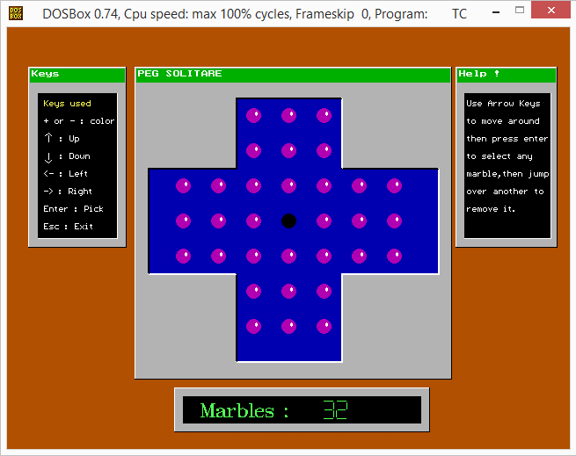

Neha Yadav 1507012137

Prashant Mall 15070121146

Rajeshwar Singh 15070121150

Yamini Gahlot 15070121169

# INTRODUCTION

Peg Solitaire is basic puzzle game made using concepts of graphics in C++.

The aim of the game is to clear all the marbles until only one is left.

The player loses if there are more than one marbles left with no more valid moves.

# CONCEPTS USED

* Looping constraints
* Conditional statements
* Functions
* Graphics
* BIOS interrupt calls

# HEADERS USED

* Graphics.h

This interface provides access to simple graphics functions.

* Stdlib.h

Used for exit() function.

* Iostream.h

This is used for basic input / output operations.

* Conio.h

This header is used for console input / output operations like kbhit() and getch().

* Dos.h

This header is containing functions for handling interrupts, producing sound and delay.

* Time.h

Contains functions to manipulate date and time.

* Bios.h

This header is used to make use of bioskey command.

# FUNCTIONS

**User Defined Functions**

* Function to open graph

**void Graph();**

* Function to create marbles

**void Marble(int x, int y, int col);**

* Function to create background

**void Background();**

* Function to draw board

**void DrawBoard();**

* Fnction to get board

**int GetBoard(int X, int Y);**

* Function to set board

**void SetBoard(int X, int Y, int element);**

* Function for intro screen

**void Intro();**

* Function for creating shadows

**void winp(int sx, int sy, int ex, int ey, int state);**

* Function for creating dialog boxes with title bar

**void win(char *text, int sx, int sy, int ex, int ey, int ck);**

* Function to draw border

**void DrawBorder(int x, int y);**

* Function to generate LCD style numbers

**void LCD(int left, int top, int NUM);**

**void Lcd(int x, int y, int n);**

* Function to perform blink action

**void Blink(int x, int y, int c);**

* Function which handles all functions and perform moves

**void Init();**

* Function to get current coordinates

**int GetXY(int X, int Y);**

* Function to check for valid moves

**int check();**

* Function to make a move

**int MakeMove(int X, int Y);**

* Funtion to display finish page

**int finish();**

**Built in Functions**

* **Kbhit()** : Used to determine if key has been pressed or not.
* **Clock()** : Returns the number of clock ticks elapsed since program was launched.
* **Graphresult()** : Returns error code for last graphics operations.
* **Grapherrormsg()** : Displays error message corresponding to error code.
* **Imagesize(x1, y1, x2, y2)** : Returns bytes required to store image in memory.
* **Initgraph(gd, gm, path)** : To initialize the graph.
* **Closegraph()** : To close the currently open graph.
* **Setfillstyle(style, color)** : Set style and color according to the arguments.
* **Setcolor(color)** : Set the color.
* **Fillellipse(x, y, r1, r2)** : Used to draw solid ellipse at (x, y) having major and minor axes as r1 and r2 respectively.
* **Bar(x1, y1, x2, y2)** : Used to draw bar with top left coordinates (x1, y1) and bottom right coordinates (x2, y2).
* **Settextstyle(font, direction, size)** : Used to set the text style to respective font and size in horizontal or vertical direction.
* **Outtextxy(x, y, text)** : Used to display the given text at (x, y).
* **Line(x1, y1, x2, y2)** : Used to draw a line between coordinates (x1, y1) and (x2, y2).
* **Setfillpattern(pattern, color)** : Used to create user defined pattern of given color.
* **Rectangle(x1, y1, x2, y2)** : Used to draw rectangle with top left coordinates (x1, y1) and bottom right coordinates (x2, y2).
* **Setwritemode(mode)** : Decides the mode of writing on graph.

1. COPY_PUT : Overwrites with the line whatever is on the screen.
2. XOR_PUT : Combines the line with screen.

* **Sound(frequency)** : Produces sound of given frequency.
* **Delay(millisec)** : Produces delay for given milli seconds.
* **Nosound()** : To stop the current sound.

# C:\Users\hp\AppData\Local\Microsoft\Windows\INetCacheContent.Word\IMG-20161017-WA0002.jpgFLOW CHARTS

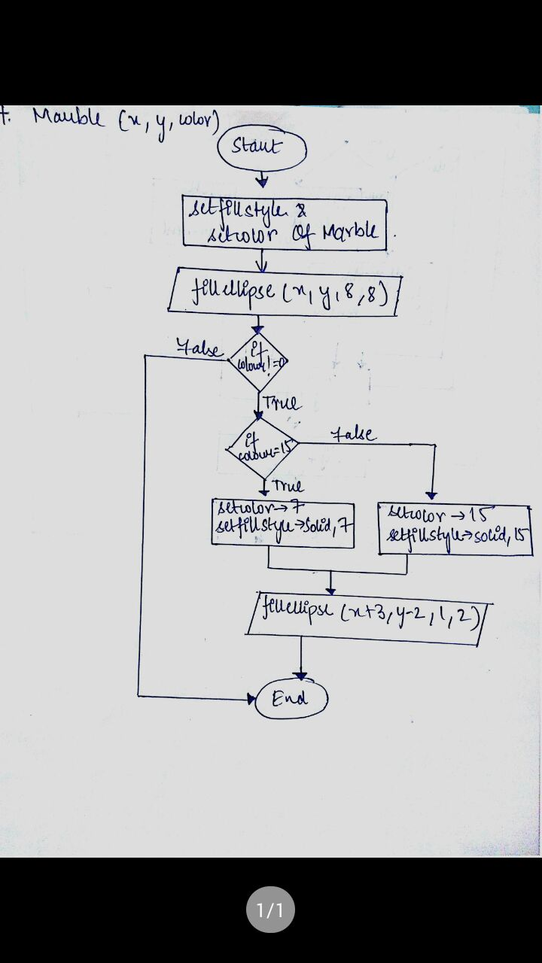

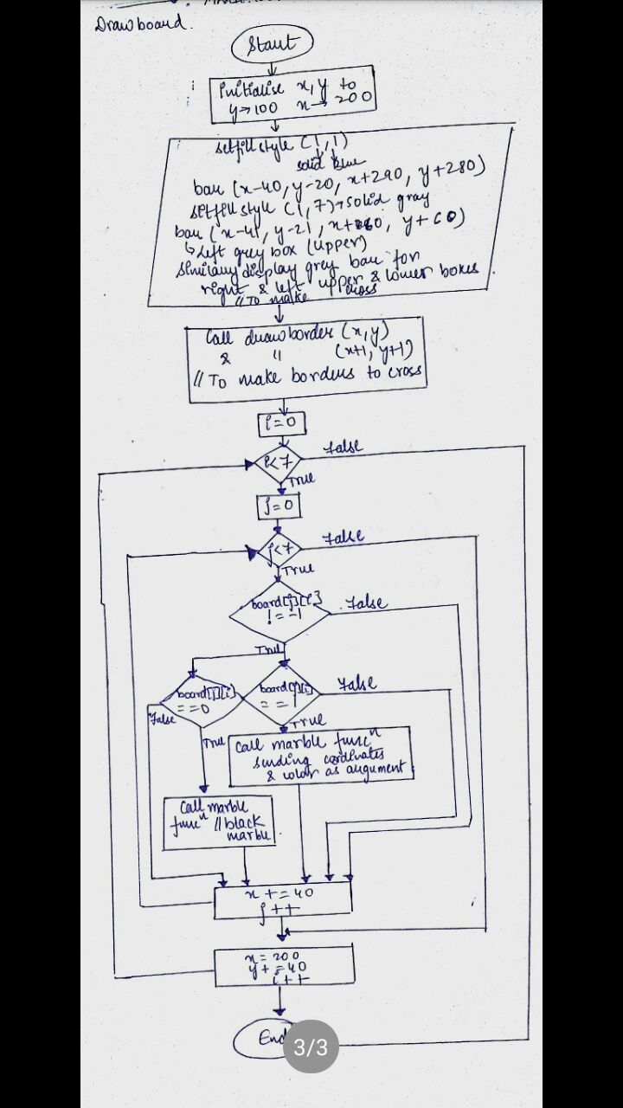

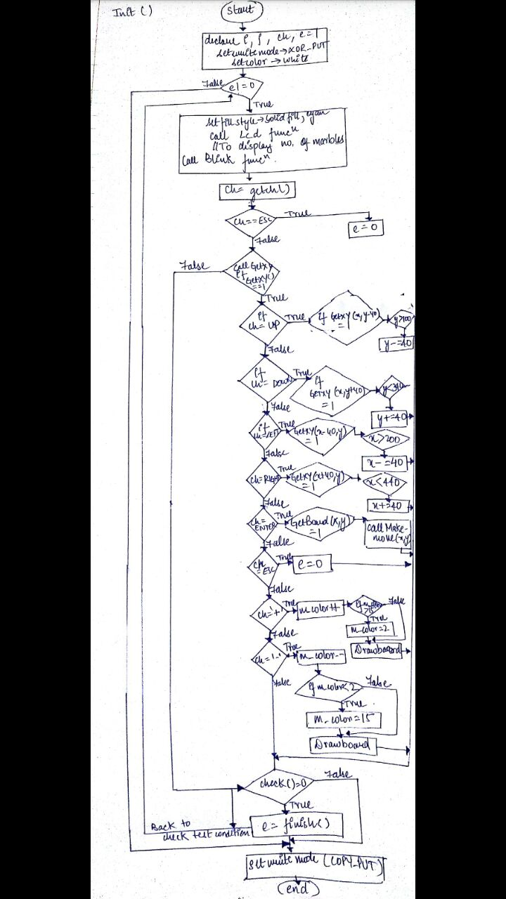

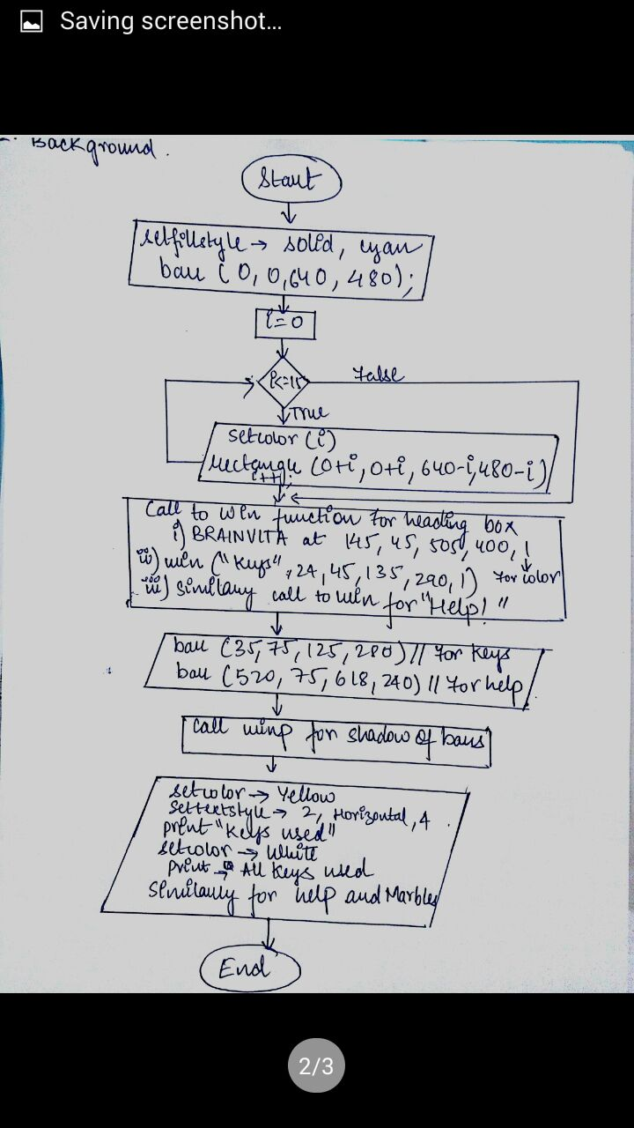

# C:\Users\hp\AppData\Local\Microsoft\Windows\INetCacheContent.Word\1p.pngOUTPUTS

